Contents
1. Create basic table 1
Create a table by using statement 1
Create a table by using a template 2
Create a table by using graphic tool 2
2. Table Constraints 3
Table Level 3
Using graphic tool 3
Using statement 10
Column Level 11
3. Table Indexes 11
4. Identity demo 12
Using Graphic tool 12
Using statement 13
Code Sample 13
5. Truncate Demo 14

Create basic table
This demostrates creating a table (without constraints, index...) by using statement or template or graphic tool.

Create a table by using statement
- Enter below statement in query editor and click Execute
CREATE TABLE Employee(
EmployeeID int
, FirstName nvarchar(100)
, LastName nvarchar(100)
, NationalIDNumber nvarchar(15)
, ManagerID int
, Title nvarchar(50)
, BirthDate datetime
, MaritalStatus nchar(1)
, Gender nchar(1)
, IsDeletedFlag bit
)

Create a table by using a template
- Double click Create Table under Table folder in Template Browser
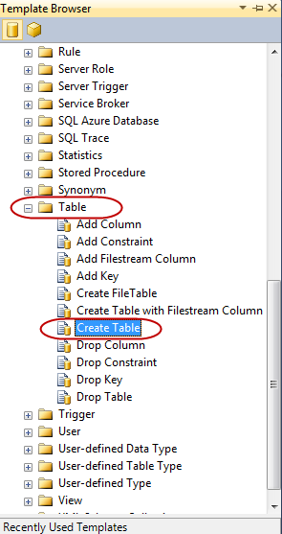
- In the template we can write statement to create a table

Create a table by using graphic tool

- Right click on Tables and choose New Table...
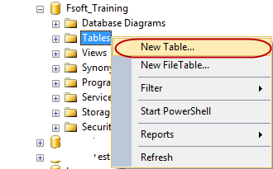
- In the designer, enter table columns in Column Name, choose Data Type from combobox as below
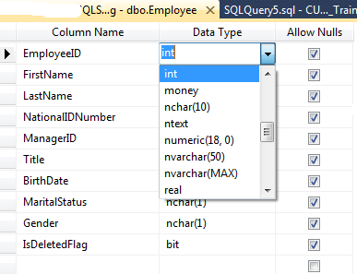

Table Constraints
This demo show you the way create constraints as NOT NULL, CHECK, UNIQUE, PRIMARY KEY, DEFAULT, FOREIGN KEY.

Table Level

Using graphic tool
- Create NOT NULL constraint
- Right click on Employee table that created in the previous demo and choose Design
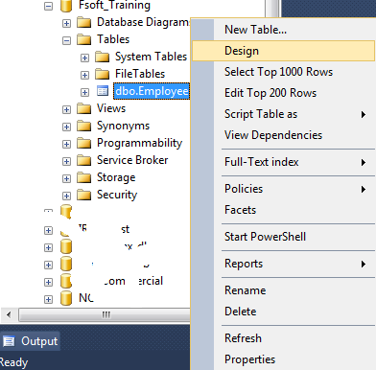

- In the Designer uncheck Allow Nulls for EmployeeID, FirstName, LastNAme, NationalIDNumber, BirthDate, Gender and IsDeletedFlag. This means these columns are not null. Then click Save
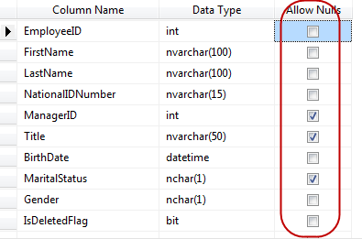
- If we try to insert a NULL value into one of these columns we will get error as below
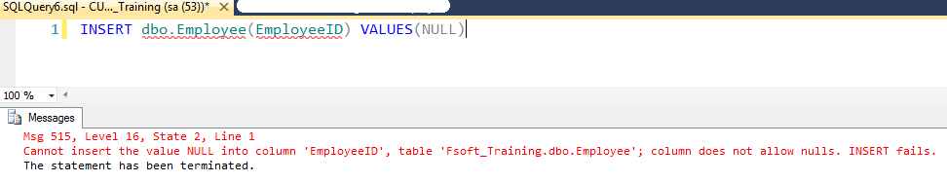
- Create CHECK constraint
We enforce MaritalStatus is 'S' (Single) or 'M' (Married)
- Right click on MartialStatus and choose Check Constraints...
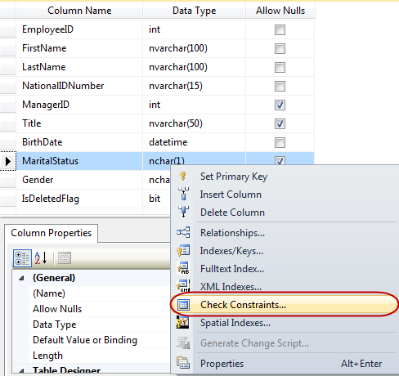
- In Check Constraints dialog, click Add buton then enter CK_MaritalStatus as constraint Name, and enter MaritalStatus = 'M' OR MaritalStatus = 'S' into Expression. click Close and then Save button

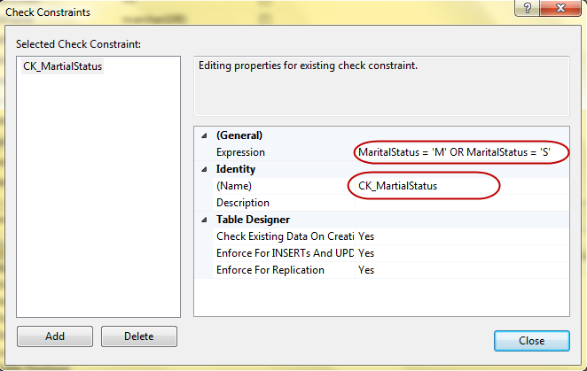
- Create UNIQUE constraint
We are going to make NationalIDNumber as unique column.
- Right click on NationalIDNumber and choose Indexes/Keys...
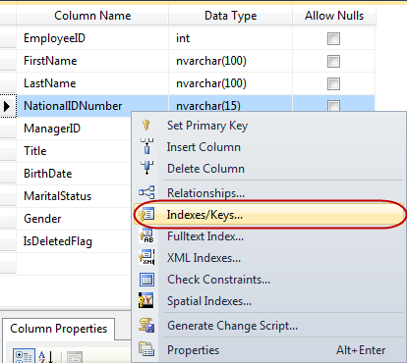
- In Selected Primary/ Unique Key or Index dialog, click Add button and then choose Unique Key as Type and enter IX_Employee_NationalIDNumber as Name. Click Close button and choose Save
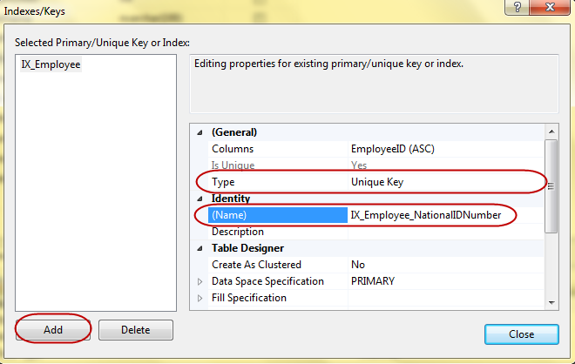
- Primary Key
We will set EmployeeID as primary key for this table.
- Right click on EmployeID and choose Set Primary Key, then click Save
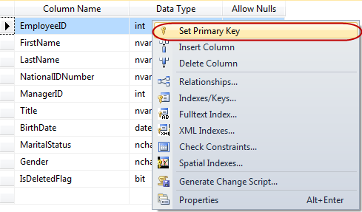
- Create Default Value constraints
We'll set 0 as default value for IsDeletedFlag
- Click on IsDeletedFlag column, in the Column Properties, enter 0 into Default Value or Binding. Click Save button
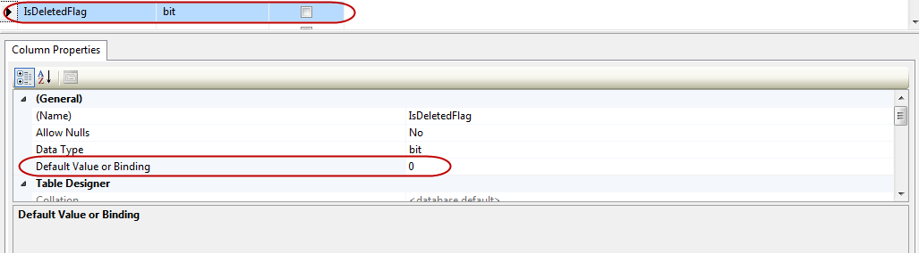
- Create Foreign Key constraint
We will a foreign key on ManagerID
- Right click on ManagerID and choose Relationships...

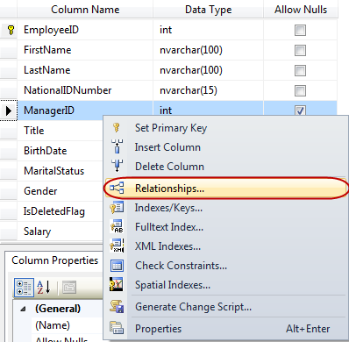
- Click Add and rename to FK_Employee_ManagerID, choose Foreign Key Base Table as Employee, Foreign Key Columns is EmployeeID click Save
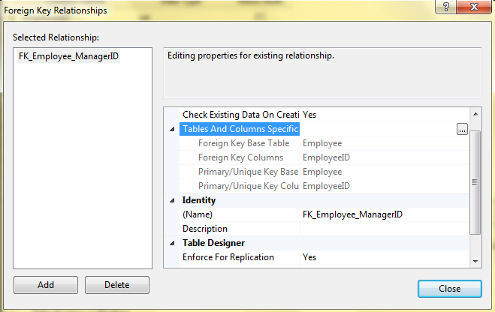

Using statement
We can create the Employee and its constraints... by using below statement.
USE [Fsoft_Training]
GO

CREATE TABLE [dbo].[Employee](
[EmployeeID] [int] IDENTITY(1,1) NOT NULL,
[FirstName] [nvarchar](100) NOT NULL,
[LastName] [nvarchar](100) NOT NULL,
[NationalIDNumber] [nvarchar](15) NOT NULL,
[ManagerID] [int] NULL,
[Title] [nvarchar](50) NULL,
[BirthDate] [datetime] NOT NULL,
[MaritalStatus] [nchar](1) NOT NULL,
[Gender] [nchar](1) NOT NULL,
[IsDeletedFlag] [bit] NOT NULL,
[Salary] [decimal](19, 4) NULL,
CONSTRAINT [PK_Employee] PRIMARY KEY CLUSTERED
(
[EmployeeID] ASC
)WITH (PAD_INDEX = OFF, STATISTICS_NORECOMPUTE = OFF, IGNORE_DUP_KEY = OFF, ALLOW_ROW_LOCKS = ON, ALLOW_PAGE_LOCKS = ON) ON [PRIMARY],
CONSTRAINT [IX_Employee_NationalIDNumber] UNIQUE NONCLUSTERED
(
[EmployeeID] ASC
)WITH (PAD_INDEX = OFF, STATISTICS_NORECOMPUTE = OFF, IGNORE_DUP_KEY = OFF, ALLOW_ROW_LOCKS = ON, ALLOW_PAGE_LOCKS = ON) ON [PRIMARY]
) ON [PRIMARY]

GO

ALTER TABLE [dbo].[Employee] ADD CONSTRAINT [DF_Employee_IsDeletedFlag] DEFAULT ((0)) FOR [IsDeletedFlag]
GO

ALTER TABLE [dbo].[Employee] WITH CHECK ADD CONSTRAINT [FK_Employee_ManagerID] FOREIGN KEY([EmployeeID])
REFERENCES [dbo].[Employee] ([EmployeeID])
GO

ALTER TABLE [dbo].[Employee] CHECK CONSTRAINT [FK_Employee_ManagerID]
GO

ALTER TABLE [dbo].[Employee] WITH CHECK ADD CONSTRAINT [CK_MartialStatus] CHECK (([MaritalStatus]='M' OR [MaritalStatus]='S'))
GO

ALTER TABLE [dbo].[Employee] CHECK CONSTRAINT [CK_MartialStatus]
GO

Column Level
Suppose, we only have Employee table from Create basic table demo (its means the table without constraints...)
- Create NOT NULL constraint
ALTER TABLE [dbo].[Employee]
ALTER COLUMN BirthDate DATETIME NOT NULL
GO
- Create CHECK constraint
ALTER TABLE [dbo].[Employee]
ADD CONSTRAINT [CK_MartialStatus] CHECK (([MaritalStatus]='M' OR [MaritalStatus]='S'))
GO
- Create Default Value constraints
ALTER TABLE [dbo].[Employee]
ADD CONSTRAINT [DF_Employee_IsDeletedFlag] DEFAULT ((0)) FOR [IsDeletedFlag]
GO

- Create Foreign Key constraint
ALTER TABLE [dbo].[Employee] WITH CHECK ADD CONSTRAINT [FK_Employee_ManagerID] FOREIGN KEY([EmployeeID])
REFERENCES [dbo].[Employee] ([EmployeeID])
GO

Table Indexes
We are going to create index for ManagerID column.
- Right click on ManagerID and choose Indexes / Keys...
- In the Indexes / Keys dialog choose Columns as ManagerID, Type as Index and Save
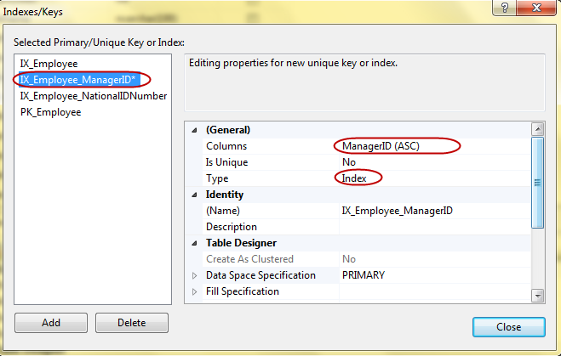

Identity demo
In this demo, we will create identity for EmployeeID column.

Using Graphic tool
- Click on EmployeeID and in Column Properties choose Yes for Identity Specification. You also can choose Identity Increment and Identity Seed. Click Save button

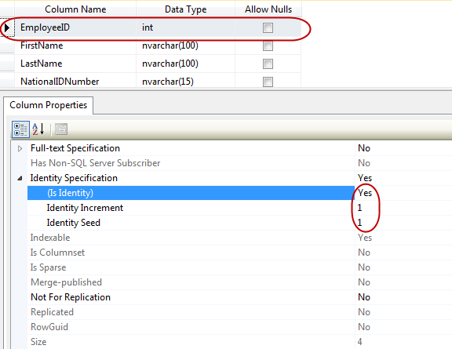

Using statement
ALTER TABLE dbo.Employee
ADD EmployeeID INT IDENTITY(1,1)

Code Sample
Suppose, we insert 2 records into Employee table without specific EmployeeID as below
USE Fsoft_Training
GO

INSERT dbo.Employee (FirstName, LastName, NationalIDNumber, ManagerID, Title, BirthDate, MaritalStatus, Gender)
VALUES ('Bill', 'Gates', '123456', NULL, 'CEO', '1959-01-01', 'M' , 'M')

INSERT dbo.Employee (FirstName, LastName, NationalIDNumber, ManagerID, Title, BirthDate, MaritalStatus, Gender)
VALUES ('Steve', 'Jobs', '123456', NULL, 'CEO', '1963-01-01', 'M' , 'M')

You can see EmployeeID is automatically increase.
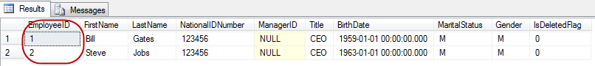

Truncate Demo
- Copy and paste following statement and Executes
TRUNCATE TABLE [dbo].[Employee]
- Then, re-insert a record into Employee table
INSERT dbo.Employee (FirstName, LastName, NationalIDNumber, ManagerID, Title, BirthDate, MaritalStatus, Gender)
VALUES ('Bill', 'Gates', '123456', NULL, 'CEO', '1959-01-01', 'M' , 'M')
- You can see EmployeeID is reseted now

- Press Alt + F1 on the table, all table structures are still remain.
